CATALOGUE
Various Belgian Goods
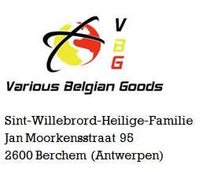

FOOD

- Cuberdons

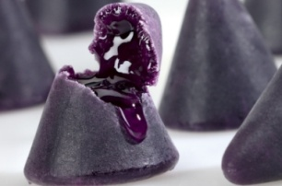
The traditional Belgian cuberdons have a flavour based on the aromas of strawberry and red fruit in combination with Arabic gum, a rare natural product from Soudan. It has a typical triangular form which is baked on a very low temperature, to keep the fluid masse insight nicely syrupy. Fresh cuberdons have a thin sugar crust which becomes thicker week after week.
- Belgian’s finest
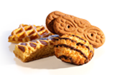
- Belgian’s finest: serie 1
A selection of our classics: crispy rolled cookies, sugar puff
pastry, almond flavored slices and apricot lattice slices.
4 tempting varieties you must try!
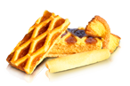
- Belgian’s finest: serie 2
A mixed case of individual wrapped "goodies": 6 pc almond
flavoured slices, 5 pc cocochoc, 5 pc caramelized cookies,
4 pc apricot lattice slices.
- Neuhaus pralines
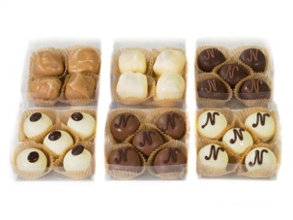
These Belgian chocolates are second choice
chocolates but this doesn’t mean the quality
and flavour are bad. Moreover these chocolates
were a commercial success in the past and we
are sure they will be so again. What makes these
chocolates second choice is that there are little
production faults in their shape but the
quality is the same as in the shops. We are able
to buy them at a low price from Neuhaus, an
international company specialised in the production
of chocolate products.
The chocolates will be sold in packets of 60gr, 250gr and 500gr. The packets contain 6 to 8 different types of chocolates. You can choose the ones that you want at the time of purchase.
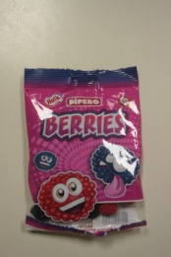
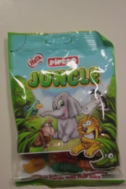
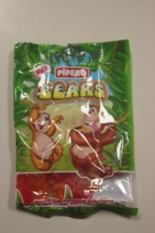
- Hellal sweets

- Belgian Lotus cookies selection
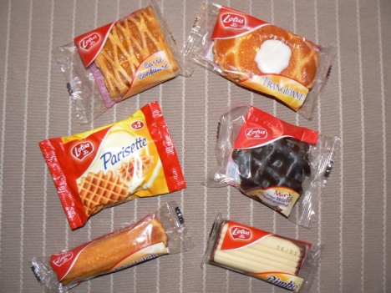
- Traditional Belgian Waffles with rich dark Belgian chocolate on one side
- Frangipane pastries feature a cake-like filling with apricot jam inside an almond-flavoured shell and topped with an icing swirl
- Carré confiture: Made in true Belgian culinary tradition, try the sweet tanginess of ripe apricots
with a light puff pastry to create a rare
gourmet experience.
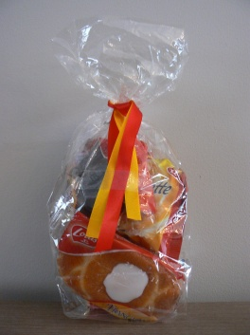
- Parisettes are a great base for a variety of desserts
because their deep waffle-patterned pockets
soak up your delicious toppings.
- Madeleine: a sweet soft cake, delicious with jam
or whipped cream
Sold individually or in a gift package.

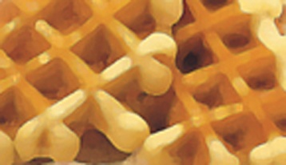
- Belgian Waffles
These are real Belgian waffles. They are so delicious that you
could eat so much of them.

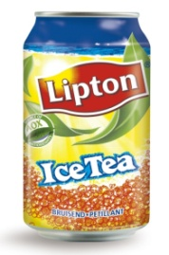
- ICE TEA
Ice tea is a form of cold tea, often served in a glass with ice.
Refreshing beverage with tea extract. Ingredients: carbonated
water, sugar, tea extract (0.32%), acid (citric acid), acidity regulator
(trisodium citrate), lemon juice from concentrated juice, aroma, antioxidant.
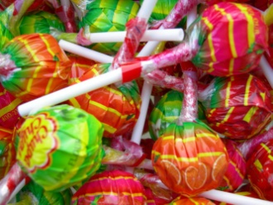
- Chupa Chups

There are many different flavours of Chupa Chups
such as cola, cherry, strawberry, lemon, apple, orange, milk

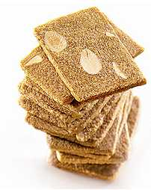
- 3 pack Jules De Strooper biscuits
This pack includes:
- Almond Thins :
A very delicate biscuit based on pure butter, candy sugar and ripe soft almonds from Valencia.
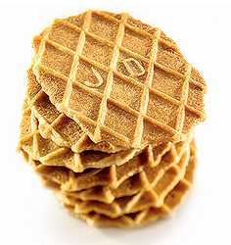
- Butter Crisp:
The butter crisps used to be a typical new-years-gift in Flanders wishing people good luck, so you could call them lucky biscuits. In fact every family used to bake its own butter waffles. This tradition dates from the 17th century.
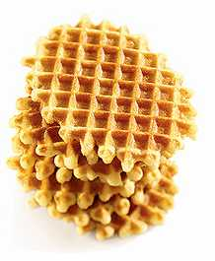
- Butter Crumble:
The founder’s son, and grandfather of today’s manager of Jules De Strooper, based his recipe of this real Belgian wafer on exquisite vanilla and pure butter.

Non-food
- Bath and shower products
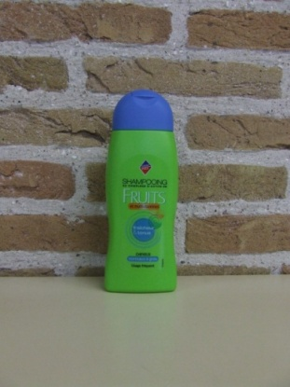
Bath products of high quality for an attractive price
will let you relax while taking a shower or taking a bath.
  - Leader Shampoo fruit

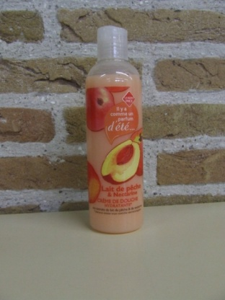
  - Lait de pêche nectarine (shower gel)


- Wish cards
Since the prior sale of wish cards went well, we decided to sell a similar
product. For this we have chosen birthday cards. To obtain a
creative design yet again, we would like to brainstorm about possible
original designs. We would like to achieve this by organizing a contest between the students of our school. The winner will receive an award with his design as a reward.

- Jewelary
Be Angeled: The Oh So Lovely collection:  BA003: fire polished glass beads, metal plated closing  Be Angeled: Mademoiselle  BAM011: fire polished glass beads, pendants | 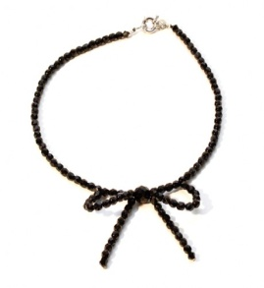  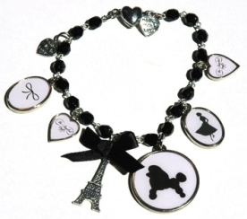

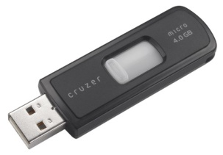
- USB-stick
These usb-sticks are really useful these days with so much
information to collect and share. These awesome sticks are
pretty cool too.

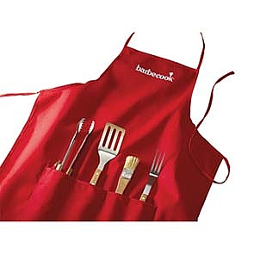
- Apron with 4 Barbecue tools
Specifications:
4 barbecue tools: turner, tongs, fork and brush
Apron in cotton

PRICELIST
Productname | Selling price Spain  (verkoopprijs) | Recommended price : sales in Spain | weight

FOOD
1.Cuberdons | € 24,00 | € 28,00 | 2 kg
2. Belgian’s finest 1 or 2 | € 7,00 | € 8,00 | 0.82 kg
3.Neuhaus pralines | € 369 (min. 12kg gift wrap included) | 500 gr.: € 25  250 gr.: € 12,5  60 gr.: € 3
4.Hellal Sweets | € 0,80 | € 0,80
5.Lotus biscuits | € 2,50 | € 3,20
6 Belgian Waffles | € 2,9 | € 3,1
7 Ice Tea | € 1,2  (Min.60 cans) | € 1,5  (Min.60 cans)
8 Chupa Chups | € 0,3  (Min. 10 bags) | € 0,5  (Min. 10 bags)
9 Jules De Strooper pack | € 7.50 | - € 9.00

NON FOOD
1a Shampoo | € 2,00 | € 2,00 | 0,300 kg
1b Lait de pêche | € 1,50 | € 2,00 | 0,300 kg
2. Wish cards
3 BA003 Necklace | € 70 | € 70
3 BAM011 Bracelet | € 45 | € 45
4 USB | € 7 | € 7,5
5 BBQ Apron | € 30 | € 32

COMPANY CONTACTS

1/ Vul hier uw bedrijfsgegevens in

Various Belgian Goods
Jan Moorkensstraat 95

2600 Berchem
Angelique Martens

SHIPPING COSTS

Kilopost International (Taxipost)
European Union
+0kg – 5 kg |  | € 30.00
+5kg – 10 kg |  | € 45.00
+10kg – 20 kg |  | € 60.00
+20kg – 30 kg |  | € 75.00

Exception: shipping costs for:
Neuhaus Pralines: € 151, 84 (for 12 kg of chocolates + gift wrap included)

